

Vulcan Football Club
Raleigh Close
Newton-le-Willows
WA12 8NN
tournaments@vulcanfootballclub.co.uk

Vulcan Festival of Football

Rules and Regulations

Coaches must be at the tent for registration at 8:30am (morning session) or 1:30pm (afternoon session).
Sat 13th June | U9 mixed – Morning  U10 mixed – Afternoon
Sun 14th June | U9 girls – Morning  U10 girls – Afternoon
Sat 20th June | U11 mixed – Morning  U12 mixed – Afternoon
Sun 21st June | U11 girls – Morning  U12 girls – Afternoon
Sat 27th June | U13 mixed – Morning  U14 mixed – Afternoon
Sun 28th June | U13 girls – Morning  U15 girls – Afternoon

• Age groups are based on the current football season 25/26.
• All standard FA Rules and Regulations apply for each format (5v5 Max 10 and 7v7 Max 14).
• All players must wear shin pads and appropriate footwear for grass pitches.
• All teams must provide a change of tops or bibs in case of a colour clash.
• No signed academy Teams are allowed.
• Goal sizes: U7–U10 use 12x6 goals, U11–U14 use 16x7 goals.
• There are no offsides.
• All matches start with a kick-off from the halfway line. The ball can be passed in any direction. Goals cannot be scored directly from kick-off.
• If a team has not arrived in time for kick-off, the match will begin once they arrive, with a 1-0 advantage awarded to the opposing team.
• Matches restart after a goal with a standard kick-off.
• Throw-ins and corner kicks follow FA guidance.
- For U7-U10 – it will be kick-ins. Cannot score directly from touch line, ball needs to be in play.
- Any headers, referee will award an in-direct free kick.
• All free kicks are direct (expect from the above).
• All goal kicks must be taken from the ground.
• Goalkeepers may not handle back passes. If they do, a direct free kick is awarded from the edge of the penalty area closest to the offence.
• An air horn will sound to start the match and again at the end of the match. If a goal-scoring opportunity is in progress, the referee has discretion to allow play to continue before blowing the final whistle.
• Scoring: 3 points for a win, 1 point for a draw, 0 points for a loss.
• Group tables are decided by points, goal difference, goals scored, head-to-head. If still level, a penalty shootout decides the ranking.
• Only semi-finals and finals will go to penalties if tied. Penalty format: 3 penalties per team, followed by sudden death.
• Only 2 coaches per team may stand pitch-side. Parents must stay behind the respect ropes.
• No parents are allowed on the pitch at any time.
• Referees are volunteers. All decisions are final. Abuse towards referees will not be tolerated.
• Trophy presentations will follow the final matches.
• Dogs are allowed on site but must be kept on a lead. Owners must clean up after them.
• Tournament officials reserve the right to remove anyone not following the rules or behaving inappropriately.
• Rubbish bags will be provided. Please dispose of all waste responsibly.
• Any questions, please contact: tournaments@vulcanfootballclub.co.uk

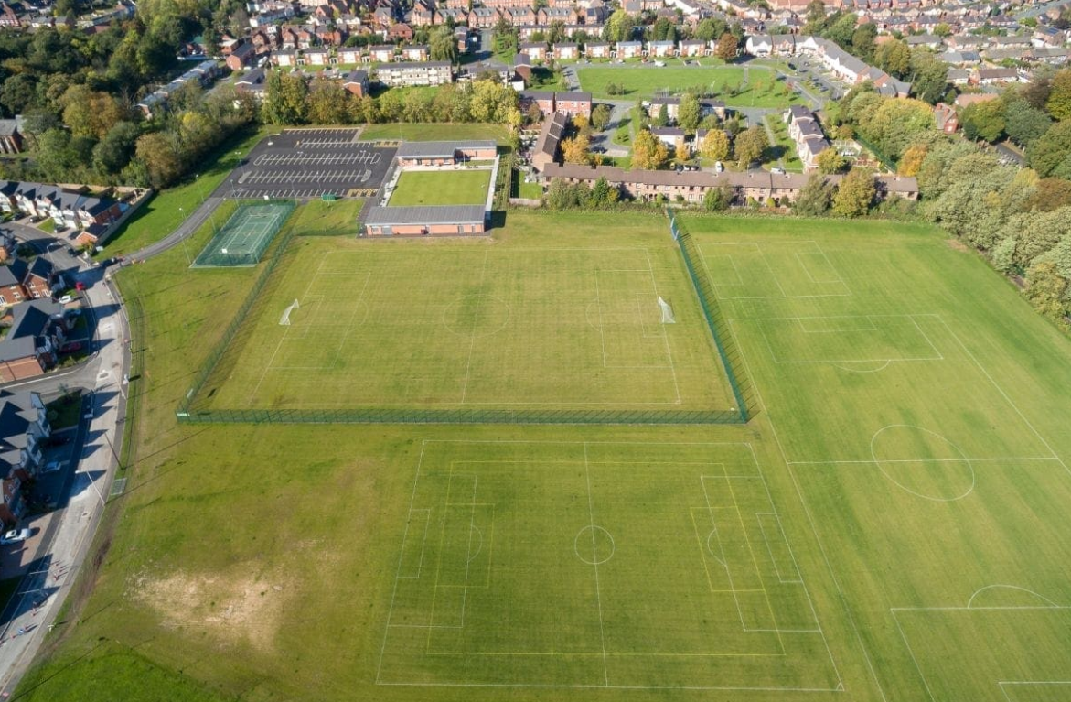
Parking
PITCH 1
PITCH 2
PITCH 3
Registration
Gazebos

TOILETS
PITCH 4

